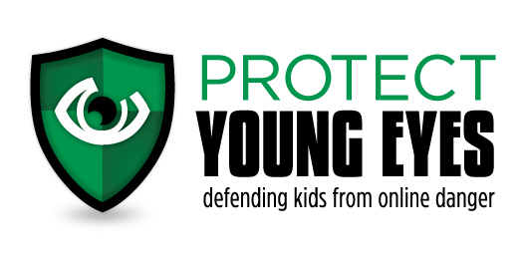
At-Home Discussion Questions
Grades 5-8 (Public Schools)

Dear Parents, Grandparents, Guardians:

Your role is so important! Especially when it comes to teaching your children about the
responsible use of technology. It’s not easy, and so the Protect Young Eyes team wants to help.

You’re receiving this because your child heard a live presentation at his/her school, and we wanted to provide some at-home guidance based on the topics that were covered.

Protect Young Eyes is a free website that explains latest apps, devices, and digital trends. There’s even a Parent Resource section with videos you can watch about pornography, social media, brain development, predators, bullies, Instagram, and more!

3 quick steps you can take right now to stay informed:
- Subscribe to our free newsletter by texting the word “protect” to 66866.
- Go to Facebook or Twitter and search for Protect Young Eyes. Like/follow us.
- Visit the website: protectyoungeyes.com/blog

Questions for Grades 5-8:

- Ask: How did it feel knowing that every click leaves a footprint out in cyberspace somewhere? Internet permanence is a real thing! Just like a giant Sharpie, right?
- Ask: Have you ever witnessed someone being a bully? Maybe in real life? What did you learn about the importance of our words?
- Say: Sometimes, the rules we have in our house related to technology might seem strict, but every time we get online, it’s like there are 100 million people standing in our front yard, staring in our front window, waiting to chat or interact with us. That’s a scary thing. I want to protect you from those strangers. Please don’t ever share anything about yourself with someone you don’t know!
- *Ask: What’s a tricky person? Have you ever had a tricky person try to talk to you on a computer or phone? What would you do if that happened? (Steps: PUT IT DOWN and TELL SOMEONE!) Parents – a “tricky person” is the new “stranger danger” from our generation. “Tricky people” are those who we might bump into online, who ask a bunch of “tricky” questions. Examples of “tricky” questions include:
  - When’s your birthday?
  - What’s your school like? Where is it?
  - Who’s your favorite teacher?
  - Where does your family live?
  - Can you keep a secret? (Remind your child that there are no good Internet secrets)
- Say: We want you to know that you are a one-of-a-kind, unique, unrepeatable person. Nothing on social media can ever change that. You have value that doesn’t come from the number of followers, likes, or comments you might have. Please, don’t ever forget that.

Note: Parents, we do not use the word pornography with grades 5-6. Although we believe kids should know this word early, and definitely by grade 5, but we need to leave that up to parents. But, if we had a chance to speak to just grades 7-8, they would have heard us use the word when talking about tricky apps and tricky pictures.

If you’re unsure how to talk about this topic with your child, visit the Resource section of Protect Young Eyes where you can find books that might help.

More Help for Families:
- How to set up parental controls on a Chromebook.
- The best iPhone parental controls.
- How to protect an Android device.

