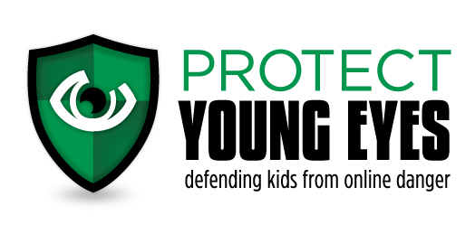
At-Home Discussion Questions
Grades 9-12 (Public)

Dear Parents, Grandparents, Guardians:

Your role is so important! Especially when it comes to teaching your children about the
responsible use of technology. It’s not easy, and so the Protect Young Eyes team wants to help.

Your child might have heard a live presentation, or maybe you used our videos at home, or maybe your church or school used our in-class curriculum. Regardless of the source, below are discussion questions for you!

Protect Young Eyes is a free website that explains latest apps, devices, and digital trends. There’s even a Parent Resource section with videos you can watch about pornography, social media, brain development, predators, bullies, Instagram, and more!

3 quick steps you can take right now to stay informed:
- Subscribe to our free newsletter by texting the word “protect” to 66866.
- Go to Facebook or Twitter and search for Protect Young Eyes. Like/follow us.
- Visit the website: protectyoungeyes.com/blog

You are the first formators of your children. It’s our passion to help your family honor God with technology.

Questions for Grades 9-12:

- Ask: You heard this phrase used: “Your Life, Your Choice: Click Well My Friend.” How did that make you feel? As a parent, it’s really difficult for me to accept that at the end of the day, I really can’t make you do much. You can choose well, or you can choose to totally wreck your life.
- Say: We don’t use technology while driving. I’ve started putting the phone in my glovebox just to avoid the temptation. Can you do the same?
- Ask: How did it feel knowing that every click leaves a footprint out in cyberspace somewhere? Internet permanence is a real thing! Just like a giant Sharpie, right?
- Say: It’s so easy to be tempted by what we see online. I want you to know that the door is wide open—we can talk about anything. Let’s keep any shame or guilt out in the open. It’s so much better that way.
- Ask/Say: Have you ever been asked to send a picture that made you uncomfortable? No matter what he/she might say, it’s not worth it. Every picture has the potential to be sent to thousands of people. You’re too special for that.”
- Say: Did you know that in most states, sending or even having partially naked pictures of you or your friends is considered creation and distribution child pornography?
- Ask: Have you ever witnessed someone being a bully? Maybe in real life? What about on technology? What would you do if someone were being mean to another kid in a game you were playing or on social media? Does this happen often at school? What did you learn about the importance of our words?
- Say: Sometimes, the rules we have in our house related to technology might seem strict, but every time we get online, it’s like there are 100 million people standing in our front yard, staring in our front window, waiting to chat or interact with us. That’s a scary thing. I want to protect you from those strangers. There are predators out there who “groom” kids to trust them all the time. I want to protect you from that!
- Note: Parents, we might mention the word “pornography” during our talks, but we don’t dwell on it at all. We believe parents should have very direct conversations about your expectations. For resources that can help with this conversation, please visit protectyoungeyes.com/resources.
- Say: We want you to know that you are a one-of-a-kind, unique, unrepeatable person with immense value. Nothing on social media can ever change that. Social media doesn’t get to dictate who you are. Please, don’t ever forget that.

More Help for Families:
- How to set up parental controls on a Chromebook.
- The best iPhone parental controls.
- How to protect an Android device.

